Guided Capstone Project Report
Problem Statements
Big Mountain Resort, a ski resort in Montana, accommodates about 350,000 customers/year. There are 11 lifts, 2 T-bars, and 1 magic carpet for novice skiers. The longest run is 3.3 miles in length. The base elevation is 4,464 ft, and the summit is 6,817 ft with a vertical drop of 2,353 ft. Big Mountain Resort has recently installed an additional chair lift (which costs $1,540,000)
How can Big Mountain Resort improve their facilities’ ROI by 5% this season by identifying facilities with higher capitalization rate and introducing a higher pricing, or by reducing costs while maintaining the ticket value?
Key Findings – Descriptive Analysis
Based on exploring the relationships between ticket price and other factors of resorts from all states, we listed out facilities/ factors with the highest correlation as below:
- Vertical drops
- FastQuads
- Runs
- Total chairs
- Snow Making area
- Night skiing capacity
Chart: Heat map showing correlations among features

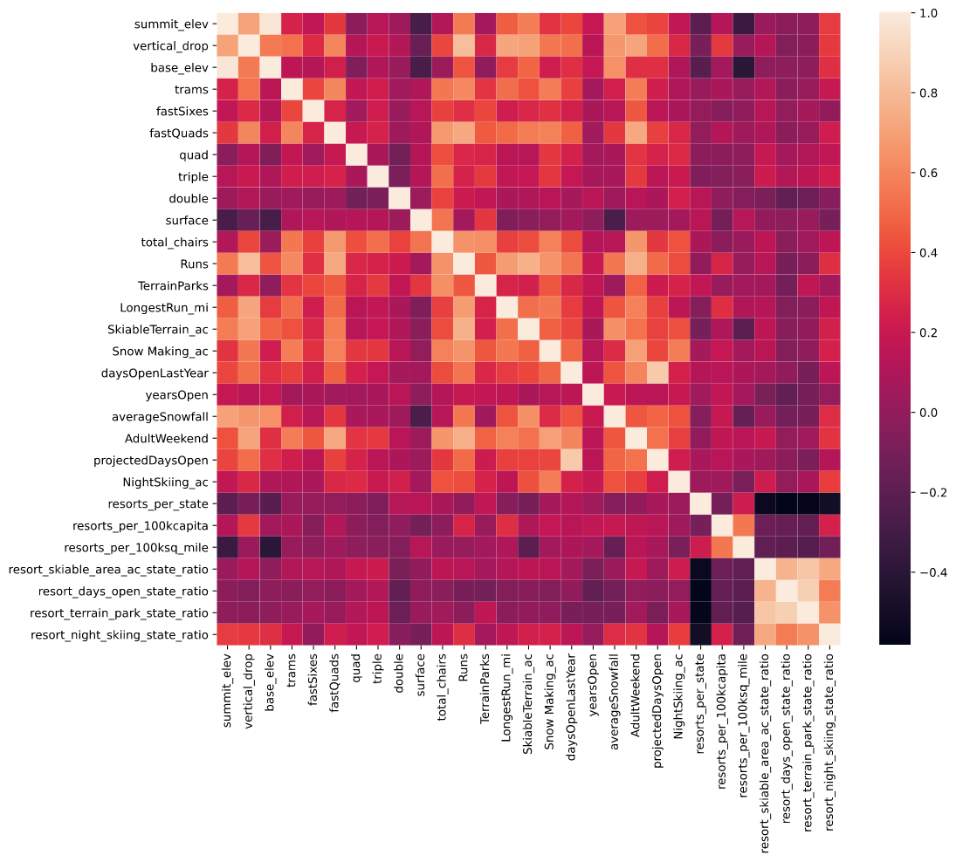
Recommendations – Prescriptive Analysis
Below are options we’ve considered and the results for each of them using the model.
Option | Projected results
- Permanently closing down up to 10 of the least used runs. This doesn't impact any other resort statistics. | The model suggests that closing down more than 1 run would negatively impact the business. (As seen above, number of Runs is one of the influencing factors to ticket price). I suggest we don’t adopt this option.
- Increase the vertical drop by adding a run to a point 150 feet lower down but requiring the installation of an additional chair lift to bring skiers back up, without additional snow making coverage | The additional chair increases operating costs by $1,540,000 this season. The model suggests that with the additional chairlift and ticket price increased by $2, we could expect to have revenue of $3,474,638. I suggest that we investigate this option further.
- Same as number 2, but adding 2 acres of snow making cover | Adding snow making cover doesn’t make any impact as compared to scenario 2. I suggest we skip this option.
- Increase the longest run by 0.2 mile to boast 3.5 miles length, requiring an additional snow making coverage of 4 acres | Since the length of the run isn’t a significant factor, the model projects that there’s no change in business revenue in this scenario. I suggest we skip this option.
Next step
We have only used facilities and market data to analyze and build the model. Next, we should investigate customer data and operating costs for other facilities. In particular,
- Historical visitor data (and volume of weekend vs. weekdays)
- Customer data (demographics, behavior, income, new vs. regular, etc.)
- Operational costs for other facilities
After improving the accuracy of the model, we will continue investigating different scenarios by changing factors and calculating the revenue and profit in each scenario. The scenarios could be:
- New ticket price doesn't affect the number of visitors.
- New ticket price affects the number of visitors by X%.
- Big Mountain keeps the old price for weekdays, and adopts an increased price for weekends.
- Big Mountain raises the price while making changes in the facilities

